Contents

USCSP301 – USCS303: Operating System (OS) Practical – 09 2

Practical – 09: Page Replacement Algorithm Least Recently Used (LRU) 2

Practical Date: 30th August 2021 2

➢ Algorithm 2

✓ Page Replacement Algorithm 2

✓ Least Recently Used (LRU) Algorithm 2

➢ Solved Example 2

✦ Example – 01 2

▪ Example – 02 4

▪ Example – 03 5

➢ Question 5

➢ Implementation 6

File Name: P9_PR_LRU_YP.java 6

➢ Input Of Example – 01 8

➢ Output Of Example – 01 8

➢ Input Of Example – 02 8

➢ Output Of Example – 02 9

➢ Input Of Example – 03 9

➢ Output Of Example – 03 9

➢ Sample Output Of Example - 01 10

➢ Sample Output Of Example – 02 10

➢ Sample Output Of Example – 03 10

**USCSP301 – USCS303: Operating System (OS) Practical – 09**

## **Practical – 09: Page Replacement Algorithm Least Recently Used** (LRU)

# Practical Date: 30th August 2021

**Practical Aim:** Page Replacement Algorithm (LRU)

# Algorithm

# Page Replacement Algorithm

* + - In demand paging memory management technique, if a page demanded for execution is present in main memory, then a page fault occurs.
    - To load the page in demand into main memory, a free page frame is searched in main memory and allocated.
    - If no page frame is free, memory manager has to free a frame by swapping its contents to secondary storage and thus make room for the required page.
    - To swap pages, many schemes or strategies are used.

# Least Recently Used (LRU) Algorithm

* + - The **Least Recently Used (LRU) algorithm** replaces the page that has not been used for the longest period of time.
    - It is based on the observation that pages that have not been used for long time will probably remain unused for the longest time and are to be replaced.

# Solved Example

#  Example – 01

* + Apply the LRU replacement algorithms for the following page-reference strings: 7,0,1,2,0,3,0,4,2,3,0,3,2
  + Indicate the number of page faults for LRU algorithm assuming demand paging with four frames.
  + Find the number of hits, number of faults and hit ratio

**Solution**

**Page Reference String:** 7,0,1,2,0,3,0,4,2,3,0,3,2

**Demand Paging or Number of Frames:** 4

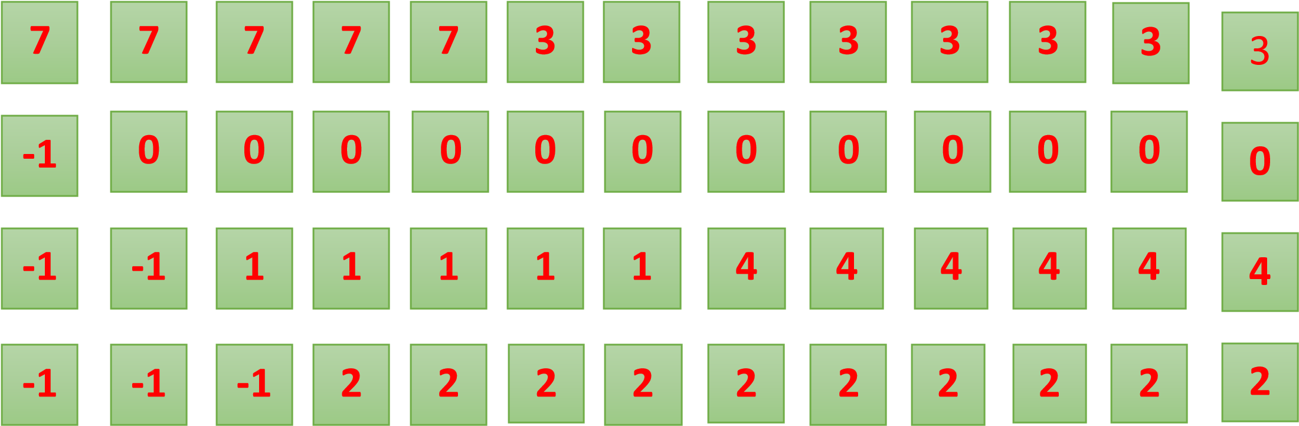

|  |  |  |  |  |  |  |  |  |  |  |  |  |
| --- | --- | --- | --- | --- | --- | --- | --- | --- | --- | --- | --- | --- |
| **7** | **0** | **1** | **2** | **0** | **3** | **0** | **4** | **2** | **3** | **0** | **3** | **2** |
|  | | | | | |  | |  |  |  |  |  |
|  |  |  |  |  |  |  |  |  |  |  |  |  |

**Number of Hits:** Count of no replacements = 7 

**Number of Faults:** Count of replacements = 6

**Hit Ratio:** Number of Hits/Len (Ref String) = 7/13 = 0.53

# Example – 02

* Consider the following example 3 frames with 1,3,0,3,5,6,3 page-reference strings.
* Find the number of hits, number of faults and hit ratio using LRU Page Replacement Algorithm.

**Solution:**

**Page Reference String:** 1,3,0,3,5,6,3

**Demand Paging or Number of Frames:** 3

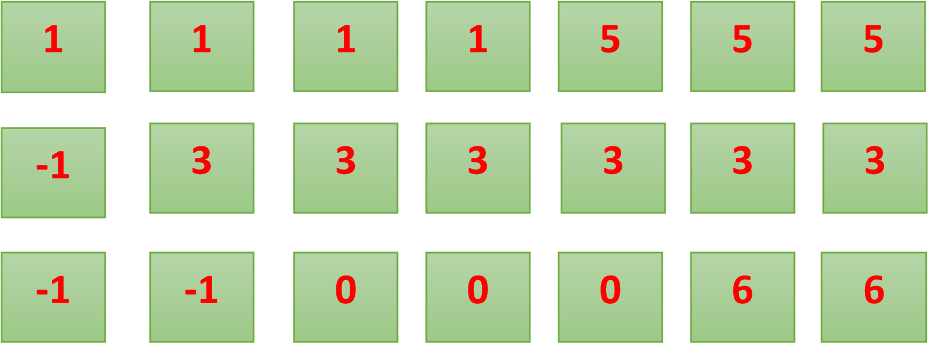

|  |  |  |  |  |  |  |
| --- | --- | --- | --- | --- | --- | --- |
| **1** | **3** | **0** | **3** | **5** | **6** | **3** |
|  | | | | | |  |
|  |  |  |  |  |  |  |

**Number of Hits:** Count of no replacements = 2 

**Number of Faults:** Count of replacements = 5

**Hit Ratio:** Number of Hits/Len (Ref String) = 2/7= 0.28

# Example – 03

* Consider the following example 3 frames with

7,0,1,2,0,3,0,4,2,3,0,3,2,1,2,0,1,7,0,1 page-reference strings.

* Find the number of hits, number of faults and hit ratio using LRU Page Replacement Algorithm.

**Solution:**

**Page Reference String:** 7,0,1,2,0,3,0,4,2,3,0,3,2,1,2,0,1,7,0,1

**Demand Paging or Number of Frames:** 3

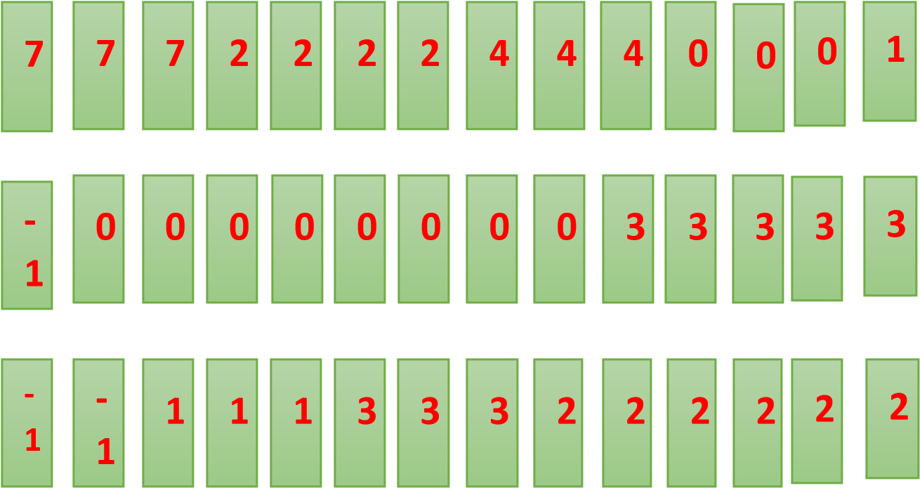

**1**



**3**



**2**



**1**



**0**



**2**



**1**



**0**



**2**



**1**



**0**



**7**



**1**



**0**



**7**



**1**



**0**



**7**

|  |  |  |  |  |  |  |  |  |  |  |  |  |  |  |  |  |  |  |  |  |  |  |  |  |  |  |  |  |  |  |  |  |  |  |  |  |  |  |
| --- | --- | --- | --- | --- | --- | --- | --- | --- | --- | --- | --- | --- | --- | --- | --- | --- | --- | --- | --- | --- | --- | --- | --- | --- | --- | --- | --- | --- | --- | --- | --- | --- | --- | --- | --- | --- | --- | --- |
| **7** | **0** | | **1** | | **2** | | | **0** | | **3** | | **0** | | **4** | | **2** | | **3** | | **0** | | **3** | | **2** | | **1** | | **2** | | **0** | | **1** | | **7** | **0** | | **1** | |
|  | |  | |  | |  |  | |  | |  | |  | |  | |  | |  | |  | |  | |  | |  | |  | |  | |  | | |  | |  | |

**Number of Hits:** Count of no replacements = 8 

**Number of Faults:** Count of replacements = 12

**Hit Ratio:** Number of Hits/Len (Ref String) = 8/20 = 0.4

# Question

* Write a Java program that implements the LRU page-replacement algorithm.

# **Implementation**

# File Name: P9_PR_LRU_YP.java

// Name: Yash Parab

// Batch: B1

// PRN: 2020016400922513

// Date: 30 August,2021

// Prac-09: Page Replacement Algorithm LRU

import java.io.*;

import java.util.*;

public class P9_PR_LRU_YP

{

public static void main(String[] args) throws IOException

{

Scanner scan = new Scanner(System.in);

int frames,pointer = 0, hit = 0, fault = 0,ref_len;

Boolean isFull = false;

int buffer[];

ArrayList<Integer>stack = new ArrayList<Integer>();

int reference[];

int mem_layout[][];

System.out.print("Please enter the number of Frames: ");

frames = scan.nextInt();

System.out.print("Please enter the length of the References strings: ");

ref_len = scan.nextInt();

reference = new int[ref_len];

mem_layout = new int[ref_len][frames];

buffer = new int[frames];

for(int j = 0; j < frames; j++)

buffer[j] = -1;

System.out.print("Please enter the references strings: ");

for(int i = 0; i < ref_len; i++)

{

reference[i] = scan.nextInt();

}

System.out.println();

for(int i = 0; i < ref_len; i++)

{

if(stack.contains(reference[i]))

{

stack.remove(stack.indexOf(reference[i]));

}

stack.add(reference[i]);

int search = -1;

for(int j = 0; j < frames; j++)

{

if(buffer[j] == reference[i])

{

search = j;

hit++;

break;

}

}

if(search == -1)

{

if(isFull)

{

int min_loc = ref_len;

for(int j = 0; j < frames; j++)

{

if(stack.contains(buffer[j]))

{

int temp = stack.indexOf(buffer[j]);

if(temp < min_loc)

{

min_loc = temp;

pointer = j;

}

}

}

}

buffer[pointer] = reference[i];

fault++;

pointer++;

if(pointer == frames)

{

pointer = 0;

isFull = true;

}

}

for(int j = 0; j < frames; j++)

mem_layout[i][j] = buffer[j];

}

for(int i = 0; i < frames; i++)

{

for(int j = 0; j < ref_len; j++)

System.out.printf("%3d",mem_layout[j][i]);

System.out.println();

}

System.out.println("The number of Hits: " + hit);

System.out.println("Hit Ratio: " +(float)((float)hit/ref_len));

System.out.println("The number of Faults: " + fault);

}

}

# Input Of Example – 01

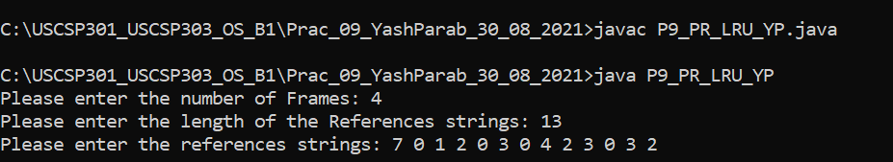

# Output Of Example – 01

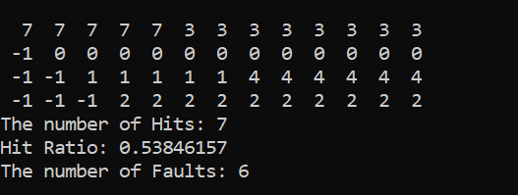

# Input Of Example – 02

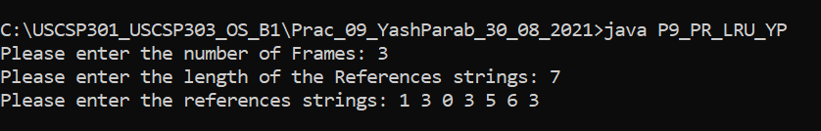

# Output Of Example – 02

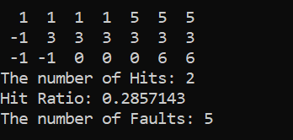

# Input Of Example – 03

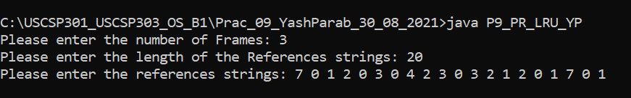

# Output Of Example – 03

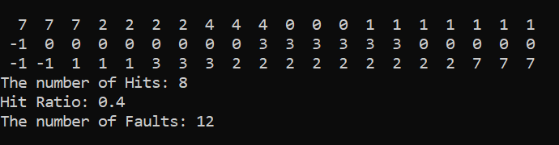

# 

# Sample Output Of Example - 01

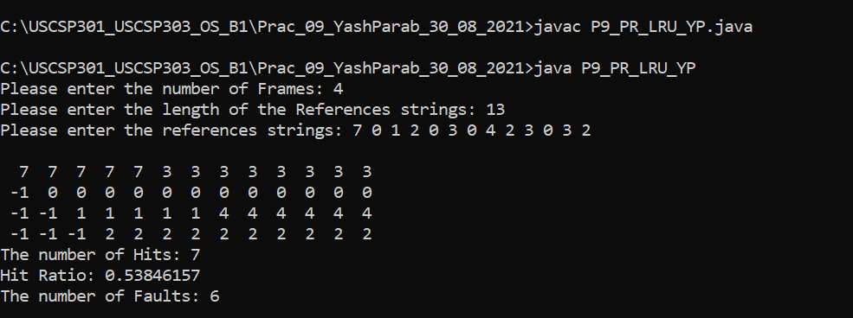

# Sample Output Of Example – 02

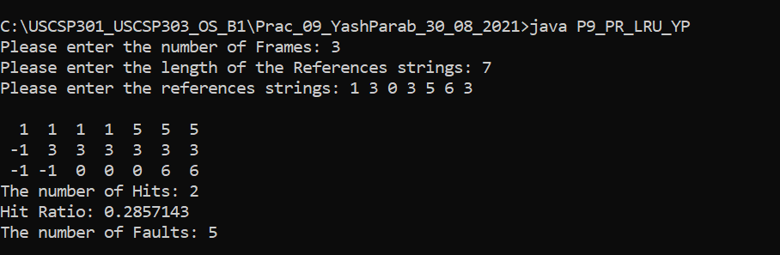

# Sample Output Of Example – 03

